Y11 PHYSICS Motion and Force: Motion and Graphing

Name: __________ ANSWERS __________________
Note:
- All answers to in metres, seconds and metres per second unless stated otherwise.
- All working must be shown for full marks and answers to 3 significant figures.

    - Jo is running around the circular school oval at a constant velocity on the 4.00 x 10² m track. If it takes 24.5 s to run halfway around the circular track what was Jo’s velocity. (3 marks)
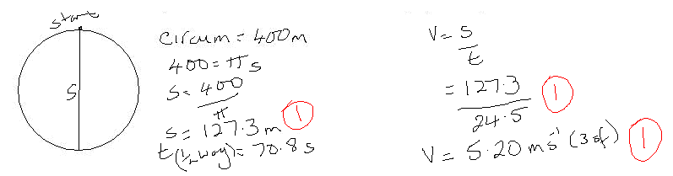
- A lion on the hunt is travelling at 34.2 km h⁻¹ when she selects her prey. She accelerates at a rate of 2.00 m s⁻² for 3.50 s to catch her prey. At that point, what was the lion’s final velocity?
(3 marks)
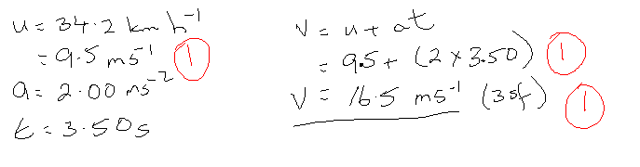
NB Q.3: Addition of vectors in two dimensions is part of the year 12 course but a good understanding in year 11 helps you in year 12. Addition of vectors in two dimension will not be part of any assessment task.

- Jen is out walking her dog. Firstly she walks 1.40 km west (to point A) then 2.80 km south (to point B). At this point she decides to heads for home by the shortest route.
  - What distance did Jen travel to point B? (1 mark)
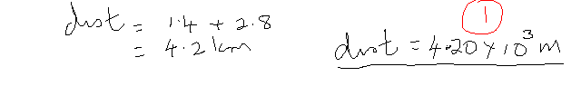
  - Determine her displacement in metres from home to point B. Include a labelled vector diagram with your answer. (3 marks)
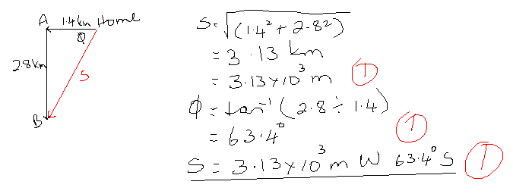
- The following graph shows the journey of a toy car.
  - Using only the graph, determine the displacement of the runner. Show all working.
(3 marks)

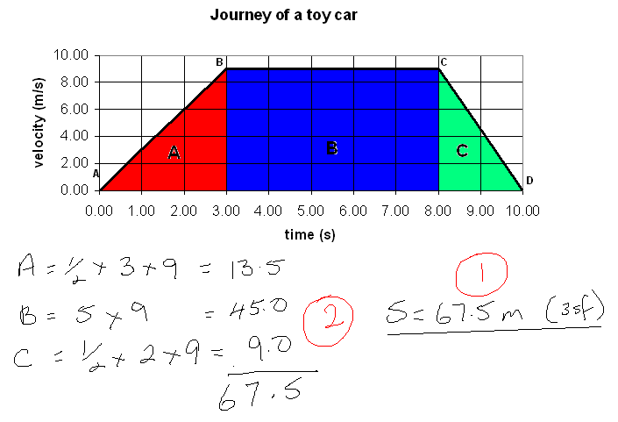

  - Calculate the acceleration between points C and D. (2 marks)
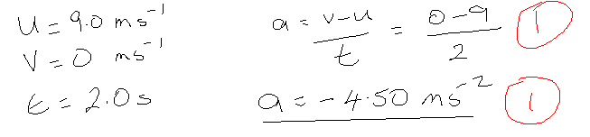

- Roger Rabbit is hopping along the field at 1.40 m s⁻¹ north when he sees a fox out hunting. He turns rapidly and hops away at 2.25 m s⁻¹ south. Calculate Roger’s change in velocity.
(3 marks)
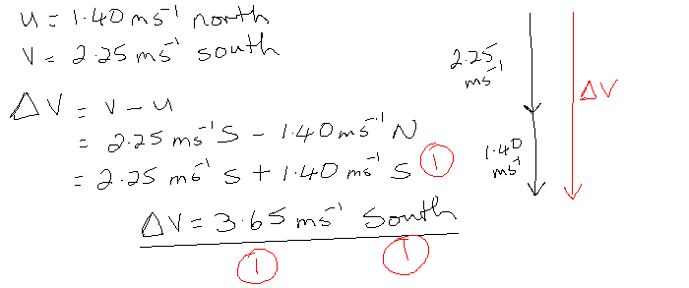
- Draw a displacement/time graph of the following situation.

A small bug is moving through the garden. It travels 1.50 m north in 15.0 s, stops for 10.0 s and then travels south for 1.00 m in 20.0 s. The bug then sees a bird and quickly travels at 0.0500 m s⁻¹ north for 40.0 s.
The space below the graph has been left for any working you need. (4 marks)

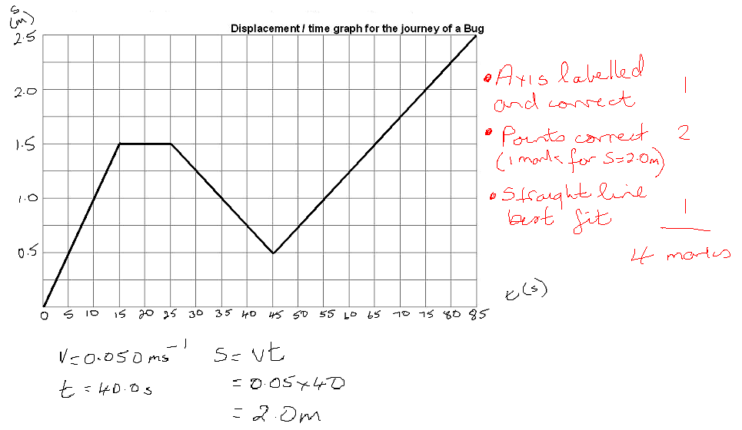

- It is three years from now, you have your licence and you are driving your own car to University. You are driving along the road at 16.4 m s⁻¹ when a car pulls out suddenly from a driveway 25.0 m in front of you. Your reaction time is 0.482 s and your car can decelerate at 7.90 m s⁻². Will you be able to stop in time? (3 marks)

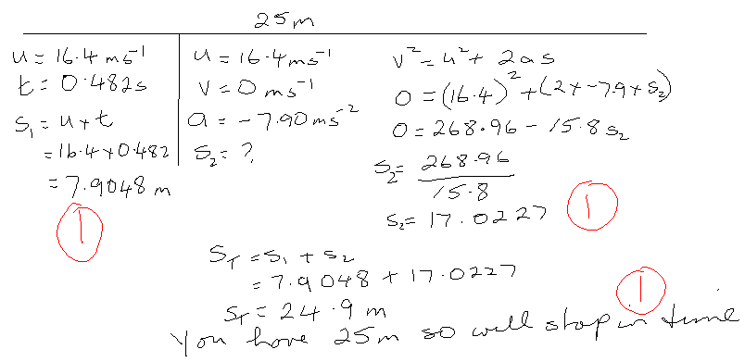
- Melissa is very angry. She just found out that her boyfriend is two-timing her. She goes to the bridge overlooking Collie River where he first asked her to go steady and, taking off the friendship ring he gave her, throws it into the water below with an initial velocity of 4.60 ms⁻¹. If the ring takes 1.250 s to hit the water, calculate:
- how far the ring was above the water? (2 marks)

This is a vertical projectiles so to prepare for Stage 3 have up as positive and down as negative.

u = -4.60 ms⁻¹ s = ut + ½ gt²
g = -9.8 ms⁻² s = (-4.6 x 1.25) + (-4.9 x 1.25²) [1 mark]
t = 1.25 s = -5.75 – 7.656
s = ? s = -13.4 m (3sf) [1 mark]

OR s = 13.4 m down (3sf)

- the ring’s velocity when it hits the water? (2 marks)

u = -4.60 ms⁻¹ v = u + gt (can also use v² = u² + 2as)
v = ? = -4.6 + (-9.8 x 1.25) [1 mark]
g = -9.8 ms⁻² = -4.6 - 12.25
t = 1.25 s v = -16.85

v = -16.9 ms⁻¹ (3sf) OR 16.9 ms⁻¹ down [1 mark]

- A hot air balloon is ascending (rising) at a constant velocity of 3.40 m s¹ when a sandbag accidentally falls out of the hot air balloon when it is 280.0 m above the ground. If the package falls to the ground,

- what will be the sandbag’s velocity when it hits the ground? (Careful, velocity is a vector quantity.) (3 marks)
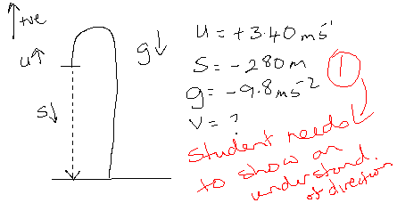
v² = u² + 2gs
= 3.4² + (2 x -9.8 x -280) [1 mark]
= 11.56 + 5488
v² = 5499.56
v = 74.159

v = 74.2 ms⁻¹ down (3sf) [1 mark]

- how long before the sandbag hits the ground from the moment it fell off the hot air balloon?
(3 marks)
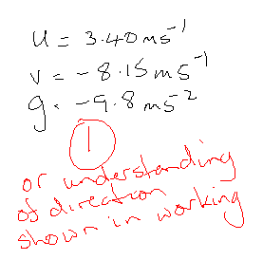
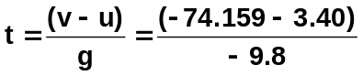 [1 mark]

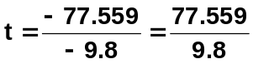

t = 7.914

t = 7.91 s (3sf) [1 mark]
- Anthony the Ant needs to get across a 30.0 cm wide conveyor belt which is moving at 2.00 cm s⁻¹. Anthony can move at 3.50 cm s⁻¹ and he needs to arrive directly opposite his starting point. In what direction should he go? Draw a diagram first. (You can leave the units in cm and cms⁻¹) (3 marks)
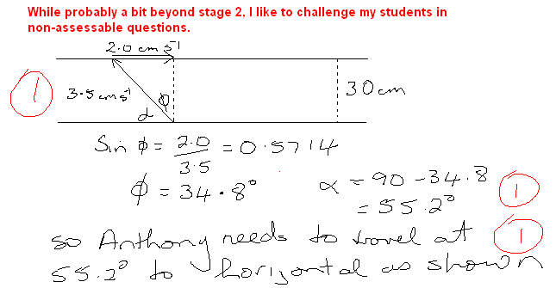

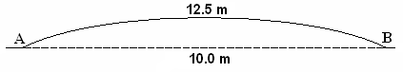
- You are walking across a new arched footbridge as shown in the diagram. The distances from A to B via the bridge and directly across are shown. If you take 4.20 s to cross the bridge
  - Calculate your speed across the bridge. (2 marks)
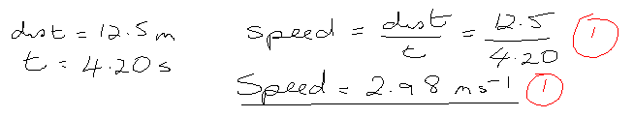

  - Calculate your velocity across the bridge. (2 marks)
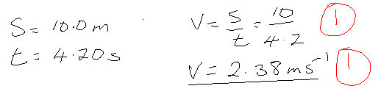

- All objects fall at an acceleration of 9.8 ms⁻². Two boys are playing a game. Firstly, one makes small paper boat then set it in the river to float under a bridge. The other boy stands on the bridge which is 14.0 m above the water and drops a small stone so as to land on the boat. If the boat is placed 12.0 m from the bridge and the river is moving at 2.50 ms⁻¹, how long after the boat is placed in the river must the stone be released so as to land on the boat. (3 marks)

